0x04. Loops, conditions and parsing

**DevOpsShellBashScripting**

* By: Sylvain Kalache
* Weight: 1
* Project over - took place from Sep 28, 2023 5:00 AM to Sep 29, 2023 5:00 AM
* An auto review will be launched at the deadline

In a nutshell…

* **Auto QA review:** 13.0/83 mandatory & 6.5/30 optional
* **Altogether:**  **19.05%**
  + Mandatory: 15.66%
  + Optional: 21.67%
  + Calculation:  15.66% + (15.66% * 21.67%)  == **19.05%**

About Bash projects

Unless stated, all your projects will be auto-corrected with Ubuntu 20.04 LTS.

Background Context

Resources

**Read or watch**:

* [Loops sample](https://intranet.alxswe.com/rltoken/wT98UJfv_E2tk4yP9PcLLw)
* [Variable assignment and arithmetic](https://intranet.alxswe.com/rltoken/olvOKX699pq50rkHRE5cSA)
* [Comparison operators](https://intranet.alxswe.com/rltoken/HxohzllkOWh0t4dy_HptIQ)
* [File test operators](https://intranet.alxswe.com/rltoken/g8of2ABPEJfCNtPrDQaqVw)
* [Make your scripts portable](https://intranet.alxswe.com/rltoken/O0Ay21p7tDhfLMsYbtAKug)

**man or help**:

* env
* cut
* for
* while
* until
* if

Learning Objectives

At the end of this project, you are expected to be able to [explain to anyone](https://intranet.alxswe.com/rltoken/UnkzDNdH09TFJ0-Y56azyg), **without the help of Google**:

General

* How to create SSH keys
* What is the advantage of using #!/usr/bin/env bash over #!/bin/bash
* How to use while, until and for loops
* How to use if, else, elif and case condition statements
* How to use the cut command
* What are files and other comparison operators, and how to use them

Requirements

General

* Allowed editors: vi, vim, emacs
* All your files will be interpreted on Ubuntu 20.04 LTS
* All your files should end with a new line
* A README.md file, at the root of the folder of the project, is mandatory
* All your Bash script files must be executable
* You are not allowed to use awk
* Your Bash script must pass Shellcheck (version 0.7.0) without any error
* The first line of all your Bash scripts should be exactly #!/usr/bin/env bash
* The second line of all your Bash scripts should be a comment explaining what is the script doing

Copyright - Plagiarism

* You are tasked to come up with solutions for the tasks below yourself to meet with the above learning objectives.
* You will not be able to meet the objectives of this or any following project by copying and pasting someone else’s work.
* You are not allowed to publish any content of this project.
* Any form of plagiarism is strictly forbidden and will result in removal from the program.

More Info

Shellcheck

[Shellcheck](https://intranet.alxswe.com/rltoken/joK6l_yEZ9N7T0GQ1RDjLA) is a tool that will help you write proper Bash scripts. It will make recommendations on your syntax and semantics and provide advice on edge cases that you might not have thought about. Shellcheck is your friend! **All your Bash scripts must pass Shellcheck without any error or you will not get any points on the task**.

Shellcheck is available on the school’s computers. If you want to use it on your own computer, here is how to [install it](https://intranet.alxswe.com/rltoken/jbz0_-i3TV3WpKgxhyrtpA).

Examples:

Not passing Shellcheck:  
  
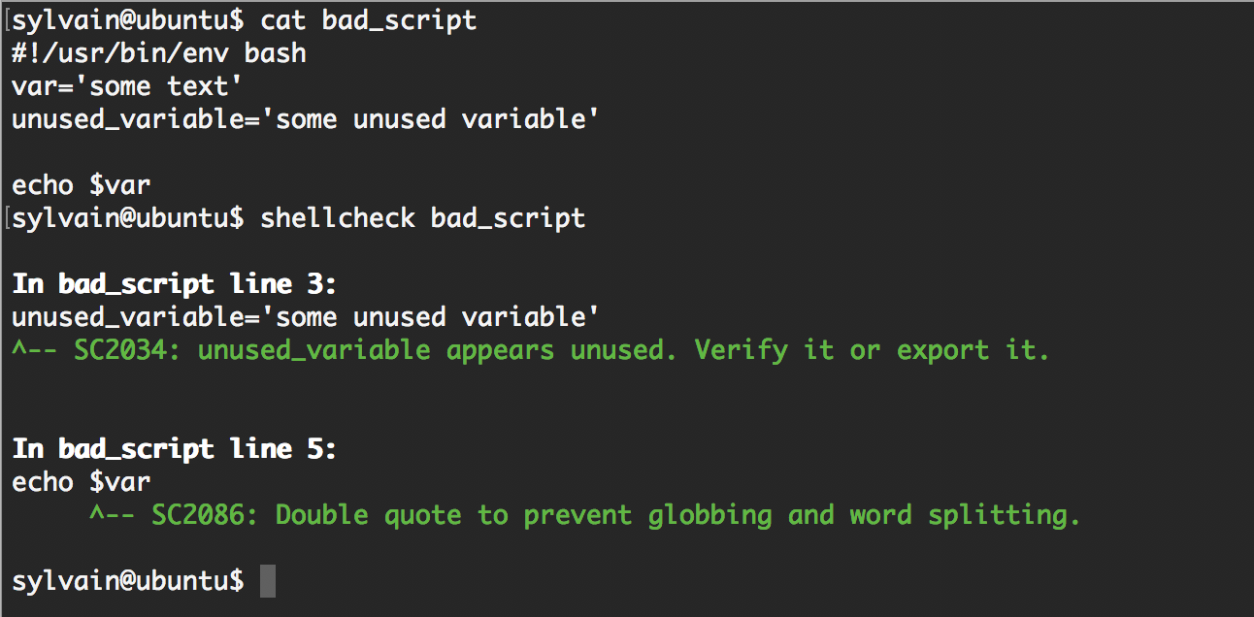

Passing Shellcheck:  
  
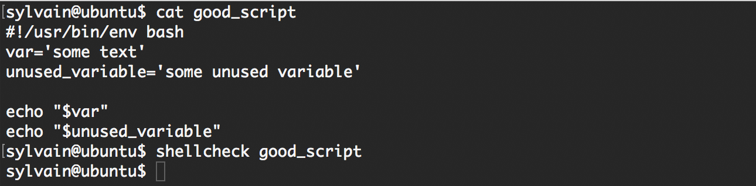

For every feedback, Shellcheck will provide a code that you can use to get more information about the issue, for example for code SC2034, you can browse [https://github.com/koalaman/shellcheck/wiki/SC2034](https://intranet.alxswe.com/rltoken/dxp49_rfO4_9Yjtcg59exg).

Tasks

0. Create a SSH RSA key pair

**mandatory**

Score: 0.0% (*Checks completed: 0.0%*)

Read for this task:

* [Linux and Mac OS users](https://intranet.alxswe.com/rltoken/Cy1plV2eR3VphjPqliXB8A)
* [Windows users](https://intranet.alxswe.com/rltoken/074M_gTsD34x3Q6MX55PDw)

man: ssh-keygen

You will soon have to manage your own **servers** concept page hosted on remote [data centers](https://intranet.alxswe.com/rltoken/nDPzEm5SYxcdGxP_OpVYXQ). We need to set them up with your RSA public key so that you can access them via SSH.

Create a RSA key pair.

Requirements:

* Share your **public key** in your answer file 0-RSA_public_key.pub
* Fill the SSH public key field of your [intranet profile](https://intranet.alxswe.com/rltoken/qsaEQ3ZWrgs-zoueDpXpPA) with the public key you just generated
* **Keep the private key to yourself in a secure location**, you will use it later to connect to your servers using SSH. Some storing ideas are Dropbox, Google Drive, password manager, USB key. Failing to do so will prevent you to access your servers, which will prevent you from doing your projects
* If you decide to add a passphrase to your key, make sure to save this passphrase in a secure location, you will not be able to use your keys without the passphrase

SSH and RSA keys will be covered in depth in a later project.

**Repo:**

* GitHub repository: alx-system_engineering-devops
* Directory: 0x04-loops_conditions_and_parsing
* File: 0-RSA_public_key.pub

 Done? Help Check your code Ask for a new correction Get a sandbox QA Review

1. For Best School loop

**mandatory**

Score: 0.0% (*Checks completed: 0.0%*)

Write a Bash script that displays Best School 10 times.

Requirement:

* You must use the for loop (while and until are forbidden)

sylvain@ubuntu$ head -n 2 1-for_best_school

#!/usr/bin/env bash

# This script is displaying "Best School" 10 times

sylvain@ubuntu$ ./1-for_best_school

Best School

Best School

Best School

Best School

Best School

Best School

Best School

Best School

Best School

Best School

sylvain@ubuntu$

Note that:

* The first line of my Bash script starts with #!/usr/bin/env bash
* The second line of my Bash scripts is a comment explaining what it is doing

**Repo:**

* GitHub repository: alx-system_engineering-devops
* Directory: 0x04-loops_conditions_and_parsing
* File: 1-for_best_school

 Done? Help Check your code Ask for a new correction Get a sandbox QA Review

2. While Best School loop

**mandatory**

Score: 0.0% (*Checks completed: 0.0%*)

Write a Bash script that displays Best School 10 times.

Requirements:

* You must use the while loop (for and until are forbidden)

sylvain@ubuntu$ ./2-while_best_school

Best School

Best School

Best School

Best School

Best School

Best School

Best School

Best School

Best School

Best School

sylvain@ubuntu$

**Repo:**

* GitHub repository: alx-system_engineering-devops
* Directory: 0x04-loops_conditions_and_parsing
* File: 2-while_best_school

 Done? Help Check your code Ask for a new correction Get a sandbox QA Review

3. Until Best School loop

**mandatory**

Score: 0.0% (*Checks completed: 0.0%*)

Write a Bash script that displays Best School 10 times.

Requirements:

* You must use the until loop (for and while are forbidden)

sylvain@ubuntu$ ./3-until_best_school

Best School

Best School

Best School

Best School

Best School

Best School

Best School

Best School

Best School

Best School

sylvain@ubuntu$

**Repo:**

* GitHub repository: alx-system_engineering-devops
* Directory: 0x04-loops_conditions_and_parsing
* File: 3-until_best_school

 Done? Help Check your code Ask for a new correction Get a sandbox QA Review

4. If 9, say Hi!

**mandatory**

Score: 10.83% (*Checks completed: 16.67%*)

Write a Bash script that displays Best School 10 times, but for the 9th iteration, displays Best School *and then* Hi on a new line.

Requirements:

* You must use the while loop (for and until are forbidden)
* You must use the if statement

sylvain@ubuntu$ ./4-if_9_say_hi

Best School

Best School

Best School

Best School

Best School

Best School

Best School

Best School

Best School

Hi

Best School

sylvain@ubuntu$

**Repo:**

* GitHub repository: alx-system_engineering-devops
* Directory: 0x04-loops_conditions_and_parsing
* File: 4-if_9_say_hi

 Done? Help Check your code Ask for a new correction Get a sandbox QA Review

5. 4 bad luck, 8 is your chance

**mandatory**

Score: 10.83% (*Checks completed: 16.67%*)

Write a Bash script that loops from 1 to 10 and:

* displays bad luck for the 4th loop iteration
* displays good luck for the 8th loop iteration
* displays Best School for the other iterations

Requirements:

* You must use the while loop (for and until are forbidden)
* You must use the if, elif and else statements

sylvain@ubuntu$ ./5-4_bad_luck_8_is_your_chance

Best School

Best School

Best School

bad luck

Best School

Best School

Best School

good luck

Best School

Best School

sylvain@ubuntu$

For the most curious:

* [8 in the Chinese culture](https://intranet.alxswe.com/rltoken/uhCfz6ariijQvbvmCyYRMg)
* [4 in the Chinese culture](https://intranet.alxswe.com/rltoken/WwpjD57ABmwWSfdUVcBhNg)

**Repo:**

* GitHub repository: alx-system_engineering-devops
* Directory: 0x04-loops_conditions_and_parsing
* File: 5-4_bad_luck_8_is_your_chance

 Done? Help Check your code Ask for a new correction Get a sandbox QA Review

6. Superstitious numbers

**mandatory**

Score: 10.83% (*Checks completed: 16.67%*)

Write a Bash script that displays numbers from 1 to 20 and:

* displays 4 *and then* bad luck from China for the 4th loop iteration
* displays 9 *and then* bad luck from Japan for the 9th loop iteration
* displays 17 *and then* bad luck from Italy for the 17th loop iteration

Requirements:

* You must use the while loop (for and until are forbidden)
* You must use the case statement

sylvain@ubuntu$ ./6-superstitious_numbers

1

2

3

4

bad luck from China

5

6

7

8

9

bad luck from Japan

10

11

12

13

14

15

16

17

bad luck from Italy

18

19

20

sylvain@ubuntu$

**Repo:**

* GitHub repository: alx-system_engineering-devops
* Directory: 0x04-loops_conditions_and_parsing
* File: 6-superstitious_numbers

 Done? Help Check your code Ask for a new correction Get a sandbox QA Review

7. Clock

**mandatory**

Score: 10.83% (*Checks completed: 16.67%*)

Write a Bash script that displays the time for 12 hours and 59 minutes:

* display hours from 0 to 12
* display minutes from 1 to 59

Requirements:

* You must use the while loop (for and until are forbidden)

Note that in this example, we only display the first 70 lines using the head command.

sylvain@ubuntu$ ./7-clock | head -n 70

Hour: 0

1

2

3

4

5

6

7

8

9

10

11

12

13

14

15

16

17

18

19

20

21

22

23

24

25

26

27

28

29

30

31

32

33

34

35

36

37

38

39

40

41

42

43

44

45

46

47

48

49

50

51

52

53

54

55

56

57

58

59

Hour: 1

1

2

3

4

5

6

7

8

9

sylvain@ubuntu$

**Repo:**

* GitHub repository: alx-system_engineering-devops
* Directory: 0x04-loops_conditions_and_parsing
* File: 7-clock

 Done? Help Check your code Ask for a new correction Get a sandbox QA Review

8. For ls

**mandatory**

Score: 41.36% (*Checks completed: 63.64%*)

Write a Bash script that displays:

* The content of the current directory
* In a list format
* Where only the part of the name after the first dash is displayed (refer to the example)

Requirements:

* You must use the for loop (while and until are forbidden)
* Do not display hidden files

sylvain@ubuntu$ ls

100-read_and_cut 1-for_best_school 6-superstitious_numbers

101-tell_the_story_of_passwd 2-while_best_school 7-clock

102-lets_parse_apache_logs 3-until_best_school 8-for_ls

103-dig_the-data 4-if_9_say_hi 9-to_file_or_not_to_file

10-fizzbuzz 5-4_bad_luck_8_is_your_chance

sylvain@ubuntu$ ./8-for_ls

read_and_cut

tell_the_story_of_passwd

lets_parse_apache_logs

dig_the-data

fizzbuzz

for_best_school

while_best_school

until_best_school

if_9_say_hi

4_bad_luck_8_is_your_chance

superstitious_numbers

clock

for_ls

to_file_or_not_to_file

sylvain@ubuntu$

**Repo:**

* GitHub repository: alx-system_engineering-devops
* Directory: 0x04-loops_conditions_and_parsing
* File: 8-for_ls

 Done? Help Check your code Ask for a new correction Get a sandbox QA Review

9. To file, or not to file

**mandatory**

Score: 7.22% (*Checks completed: 11.11%*)

Write a Bash script that gives you information about the school file.

Requirements:

* You must use if and, else (case is forbidden)
* Your Bash script should check if the file exists and print:
  + if the file exists: school file exists
  + if the file does not exist: school file does not exist
* If the file exists, print:
  + if the file is empty: school file is empty
  + if the file is not empty: school file is not empty
  + if the file is a regular file: school is a regular file
  + if the file is not a regular file: (nothing)

sylvain@ubuntu$ file school

school: cannot open `school' (No such file or directory)

sylvain@ubuntu$ ./9-to_file_or_not_to_file

school file does not exist

sylvain@ubuntu$ touch school

sylvain@ubuntu$ ./9-to_file_or_not_to_file

school file exists

school file is empty

school is a regular file

sylvain@ubuntu$ echo 'betty' > school

sylvain@ubuntu$ ./9-to_file_or_not_to_file

school file exists

school file is not empty

school is a regular file

sylvain@ubuntu$ rm school

sylvain@ubuntu$ mkdir school

sylvain@ubuntu$ ./9-to_file_or_not_to_file

school file exists

school file is not empty

sylvain@ubuntu$

**Repo:**

* GitHub repository: alx-system_engineering-devops
* Directory: 0x04-loops_conditions_and_parsing
* File: 9-to_file_or_not_to_file

 Done? Help Check your code Ask for a new correction Get a sandbox QA Review

10. FizzBuzz

**mandatory**

Score: 10.83% (*Checks completed: 16.67%*)

Write a Bash script that displays numbers from 1 to 100.

Requirements:

* Displays FizzBuzz when the number is a multiple of 3 and 5
* Displays Fizz when the number is multiple of 3
* Displays Buzz when the number is a multiple of 5
* Otherwise, displays the number
* In a list format

sylvain@ubuntu$ ./10-fizzbuzz | head -20

1

2

Fizz

4

Buzz

Fizz

7

8

Fizz

Buzz

11

Fizz

13

14

FizzBuzz

16

17

Fizz

19

Buzz

sylvain@ubuntu$

**Repo:**

* GitHub repository: alx-system_engineering-devops
* Directory: 0x04-loops_conditions_and_parsing
* File: 10-fizzbuzz

 Done? Help Check your code Ask for a new correction Get a sandbox QA Review

Top of Form



Bottom of Form

Copyright © 2023 ALX, All rights reserved.